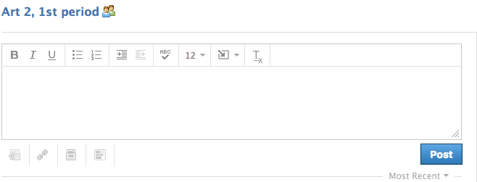

- Join GROUP in your class (enter class code)
- Upload an image
- Type in your summary
- Comment on some-one else’s post

